Form ISR-4
(see circular No. SEBI/HO/MIRSD/MIRSD_RTAMB/P/CIR/2022/8 dated January 25, 2022 on Issuance of Securities in dematerialized form in case of Investor Service Requests)
Request for issue of Duplicate Certificate and other Service Requests
(for Securities - Shares / Debentures / Bonds, etc., held in physical form)

Date: / /

A. Mandatory Documents / details required for processing all service request:
I / We are submitting the following documents / details and undertake to request the Depository Participant to dematerialize my / our securities within 120 days from the date of issuance of Letter of Confirmation, received from the RTA/Issuer Company (tick ✓as relevant, refer to the instructions):
- Demat Account No. (If available):
Provide Client Master List (CML) of your Demat Account from the Depository Participant*

- Provide the following details, if they are not already available with the RTA (see SEBI circular dated November 03, 2021 in this regard)
PAN
Nomination / Declaration to Opt-out
Specimen Signature

* (Your address, e-mail address, mobile number and bank details shall be updated in your folio from the information available in your CML). You can authorize the RTA to update the above details for all your folios. In this regard, please refer to and use Form ISR-1 in SEBI circular dated November 03, 2021.

- I / We request you for the following (tick (tick ✓as relevant):

Issue of Duplicate Certificate | Claim from Unclaimed Suspense Account
Replacement / Renewal / Exchange of securities certificate | Endorsement
Sub-division / Splitting of securities certificate | Consolidation of Folios
Consolidation of Securities Certificate | Transmission
Transposition (Mention the new order of holders here)

I / We are enclosing certificate(s) as detailed below**:
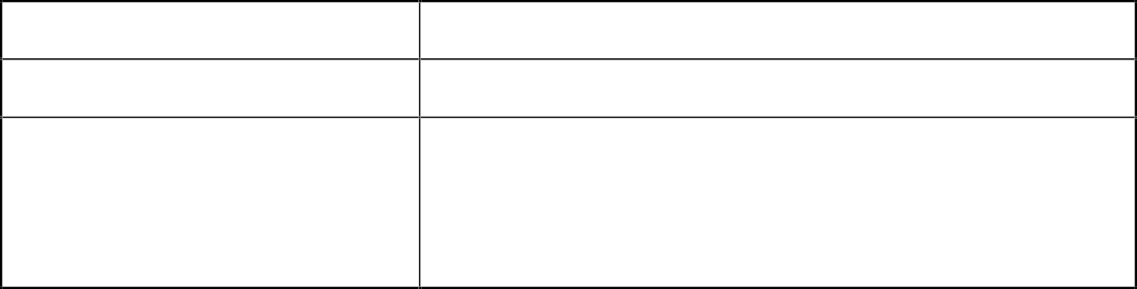
Name of the Issuer Company
Folio Number
Name(s)
holder(s)
of
as
the security
per
the
certificate(s)
1.
2.
3.

Certificate numbers
Distinctive numbers
Number  securities | & | Face | value | of
** Wherever applicable / whichever details are available

Document / details required for specific service request:
  - Duplicate securities certificate
  - Claim from Unclaimed Suspense Account
(in numbers) (in words)
Securities claimed

  - Replacement / Renewal / Exchange of securities certificate
(that is defaced, mutilated, torn, decrepit, worn out or where the page on the reverse is fully utilized)
  - Endorsement
  - Sub-division / Splitting of securities certificate
  - Consolidation of securities certificate/Folios
  - Transmission
  - Transposition
Provide / attach original securities certificate(s) for request for item numbers III to VIII above.

Declaration: All the above facts stated are true and correct to best of my / our knowledge and belief.

 | Security Holder 1/  Claimant | Security Holder 2 | Security Holder 3
Signature | ✓ | ✓ | ✓
Name | ✓ | ✓ | ✓
Full address | ✓
PIN | ✓

After processing the service request, the RTA shall issue a ‘Letter of Confirmation’ to the securities holder/claimant, which is valid only for 120 days. Using this ‘Letter of Confirmation’, the securities holder/claimant shall request the DP to dematerialize the securities, failing which the securities shall be credited to the Suspense Escrow Demat Account of the Company.

